Experiment 2
AIM: Design Employee Payroll System using Inheritance, Interface & Polymorphism
Source: Program.cs
Code:
using System;
using System.Collections.Generic;
using System.Linq;
using System.Text;
using System.Threading.Tasks;

namespace Practical_2
{
internal class Program
{
class Employee
{
public int Empid;
public string Empname;
public double Basesalary;

public Employee()
{
Console.WriteLine("-----------------------------------------");
Console.WriteLine(" Employee Payroll System");
Console.WriteLine("-----------------------------------------");
}

public void AccepDetails()
{
Console.Write("Enter Employee ID: ");
Empid = Convert.ToInt32(Console.ReadLine());

Console.Write("Enter Employee Name: ");
Empname = Console.ReadLine();

Console.Write("Enter Employee Base Salary: ");
Basesalary = Convert.ToDouble(Console.ReadLine());
}

public void DisplayDetails()
{
Console.WriteLine();
Console.WriteLine("Employee ID :" + Empid);
Console.WriteLine("Employee Name: " + Empname);
Console.WriteLine("EMployee Base Salary: " + Basesalary);
}

public virtual void CalculateNetSalary()
{
Console.WriteLine("Calculating Salary....");
}
}

class FullTimeEmp : Employee
{
public Double NetSalary;

public override void CalculateNetSalary()
{
var HRA = Basesalary * 0.20;
var DA = Basesalary * 0.10;
NetSalary = Basesalary + HRA + DA;
Console.WriteLine("Calculating Salary of Full Time Employee.....");
Console.WriteLine("Net Salary of Employee: " + NetSalary);
}
}
class PartTimeEmp : Employee
{
public Double NetSalary;

public override void CalculateNetSalary()
{
NetSalary = Basesalary;
Console.WriteLine("Calculating Salary of Part Time Employee.....");
Console.WriteLine("Net Salary of Employee: " + NetSalary);
}
}

static void Main(string[] args)
{
int choice;

Console.WriteLine("1. Full Time Employee");
Console.WriteLine("2. Part Time Employee");
Console.Write("Select the type of EMployee: ");
choice = Convert.ToInt32(Console.ReadLine());
Employee emp = null;

if (choice == 1)
{
emp = new FullTimeEmp();
}
else if (choice == 2)
{
emp = new PartTimeEmp();
}
else
{
Console.Write("Enter Valid Choice");
}
emp.AccepDetails();
emp.DisplayDetails();
emp.CalculateNetSalary();
Console.ReadKey();

}
}
}

Output:
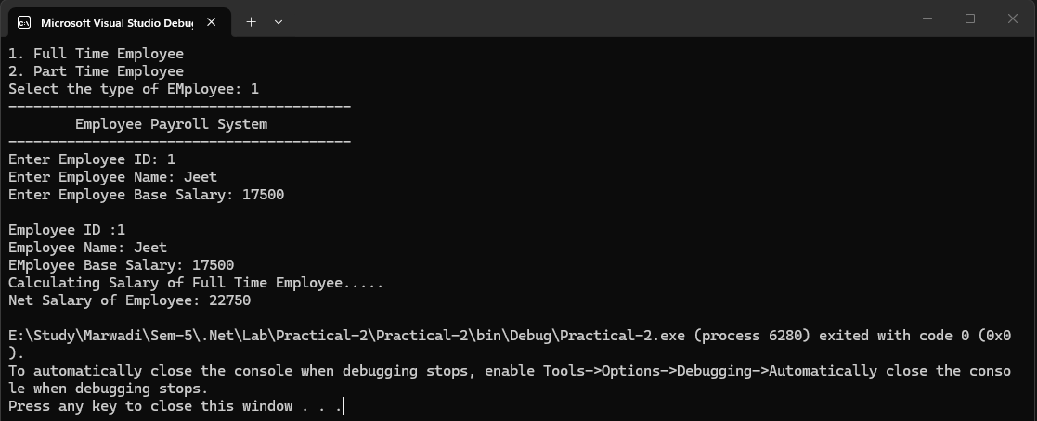
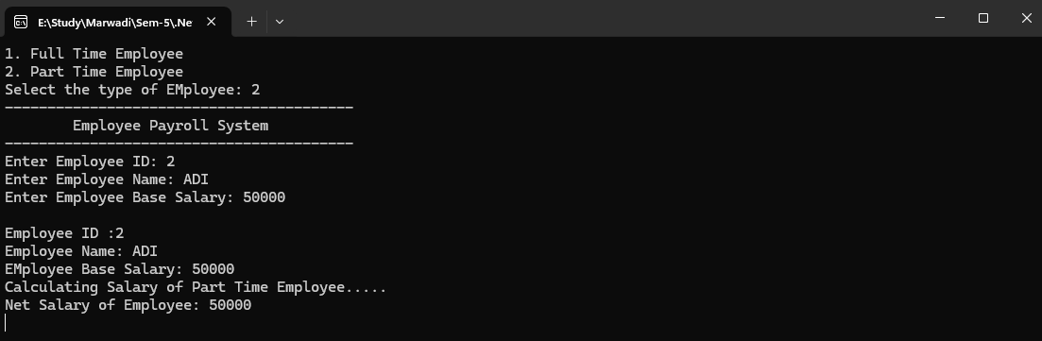

Github Url: https://github.com/jd-thakrar/Uni-DotNet-Work/tree/master/Practical-2

